**Team Members:**

Roshini Varada- 26

V H N V R S Sai Pavan -27

**Introduction:**

To deploy a node JS application on Amazon EC2 server and run on a URL.

**Objective**

To develop a simple application using Node JS and express framework and deploy it in amazon EC2 server.

**Prerequisites:**

Node JS should be installed in the machine.

**Design and Implementation:**

1. Create an account in AWS

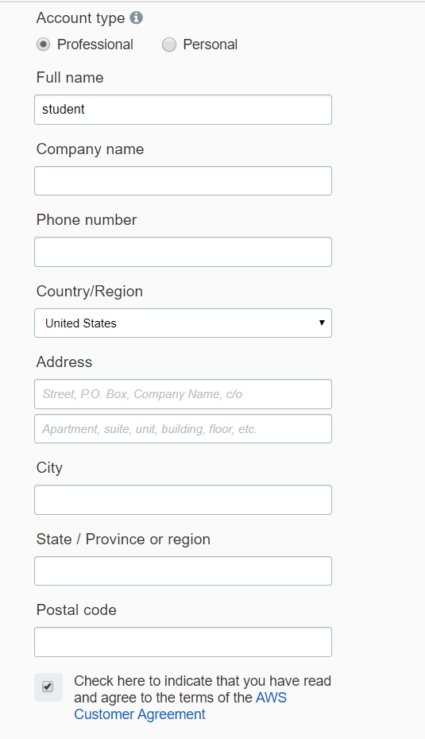

1. After that launch an EC2 instance by going into the AWS console.

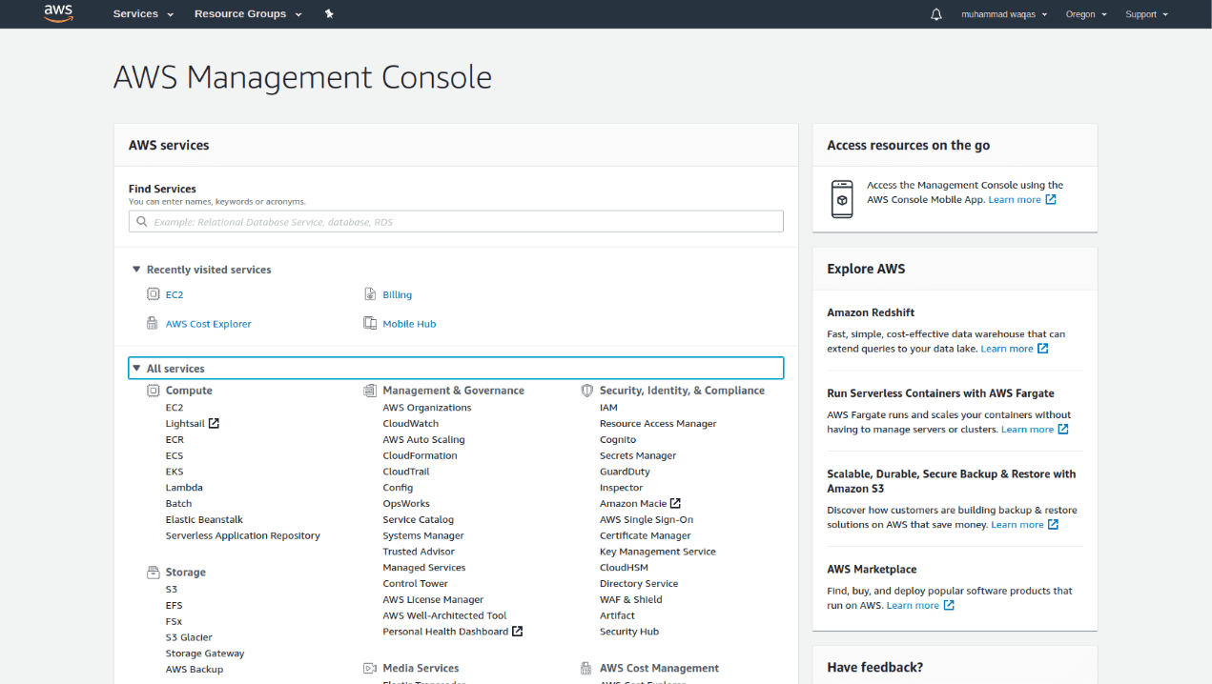

3.On EC2 instance page click on the launch instance button under create instance page.

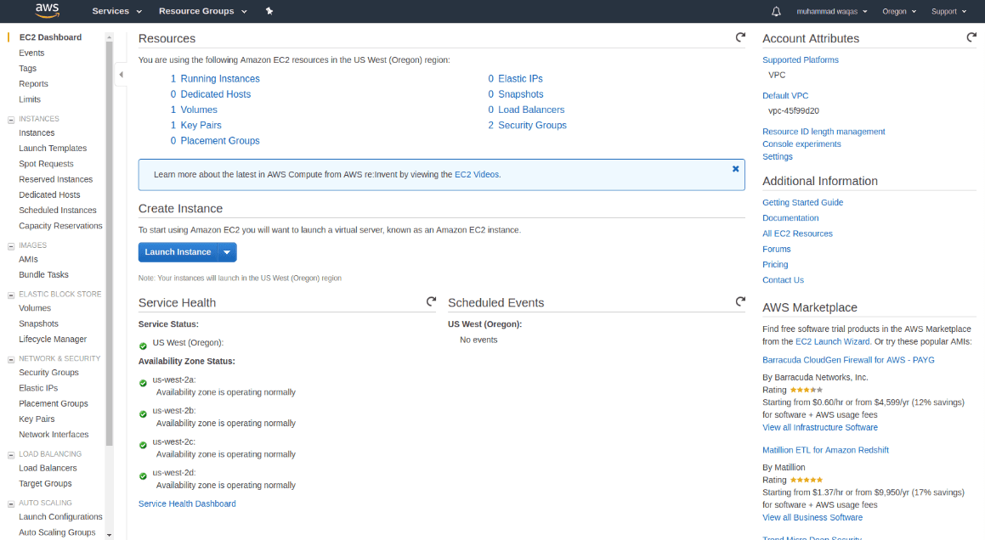

4.Choose EC2 and select instance type

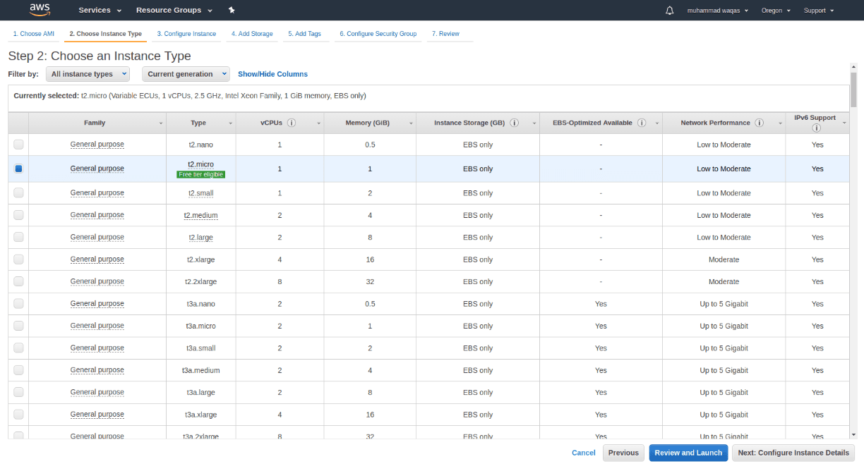

5.Configure the instance details.

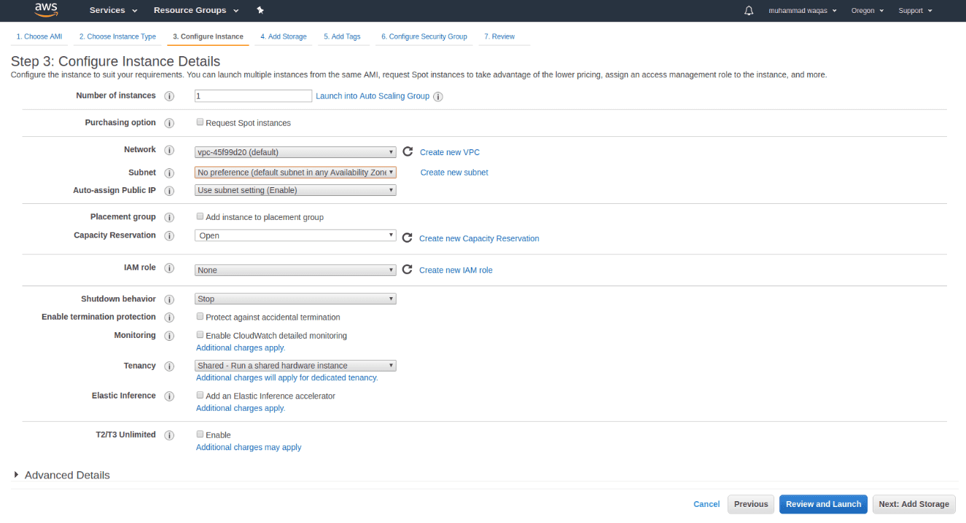

6.Set the storage details and add the tags

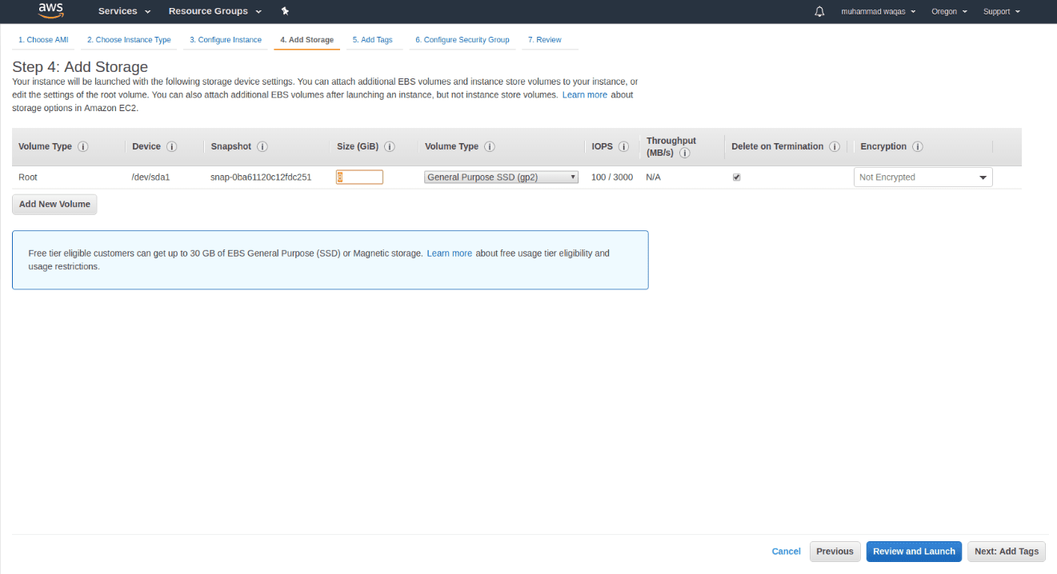

7.Add the tags as below.

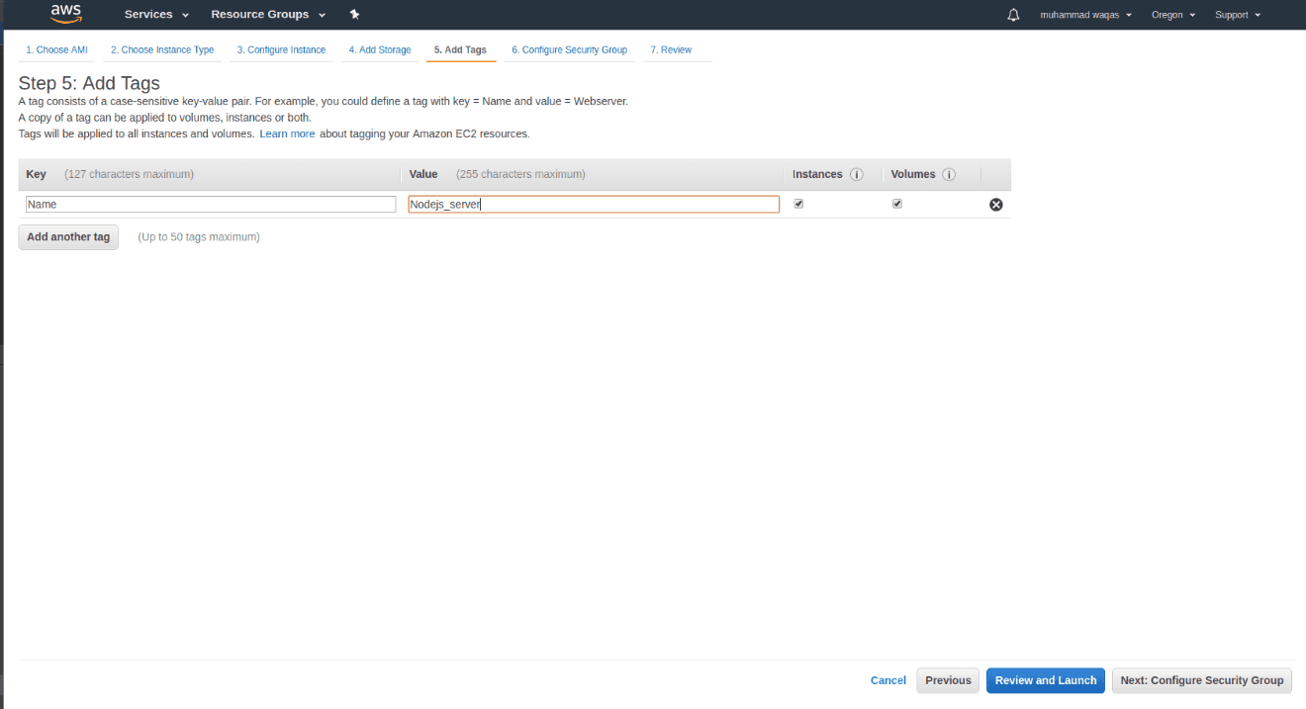

8.Click on review and launch

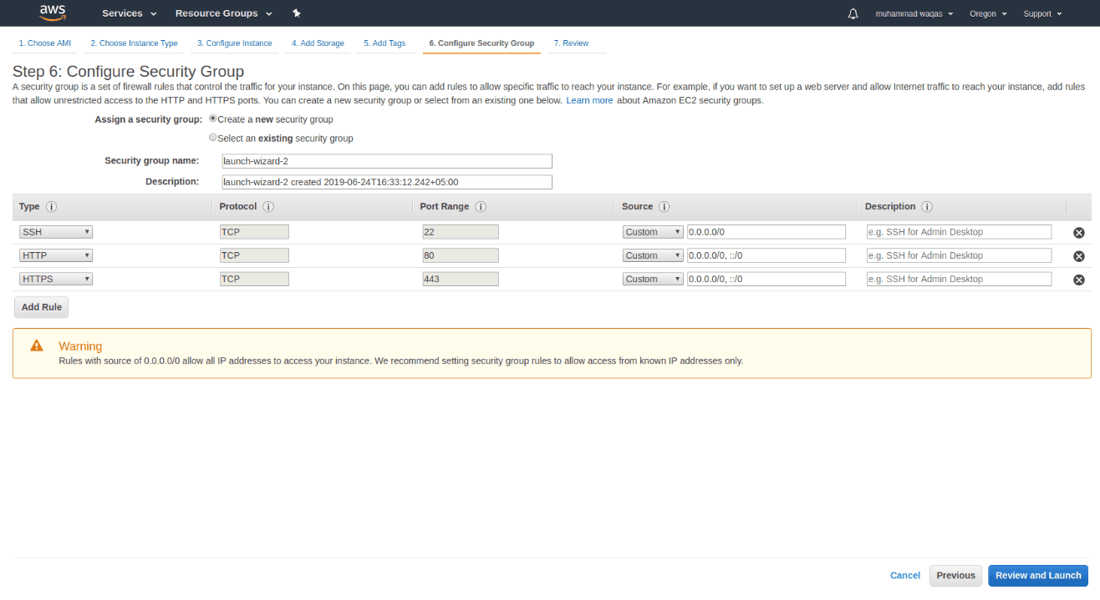

9.Generate a new key pair and click on launch instances button

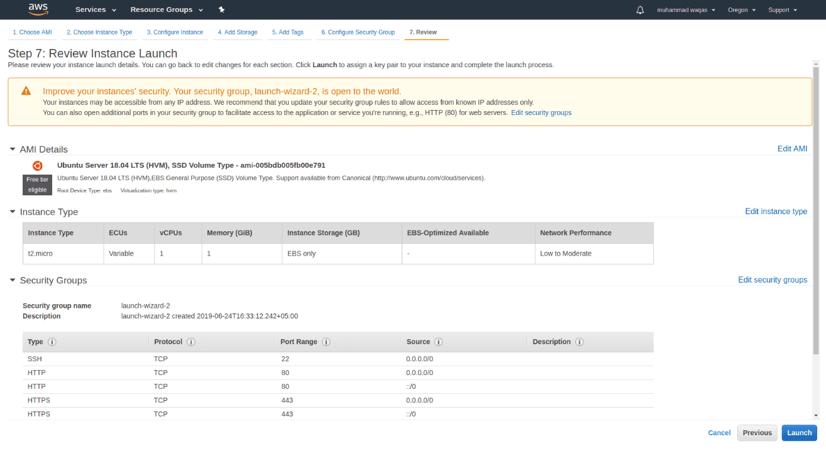

10.Add SSH to the instance.

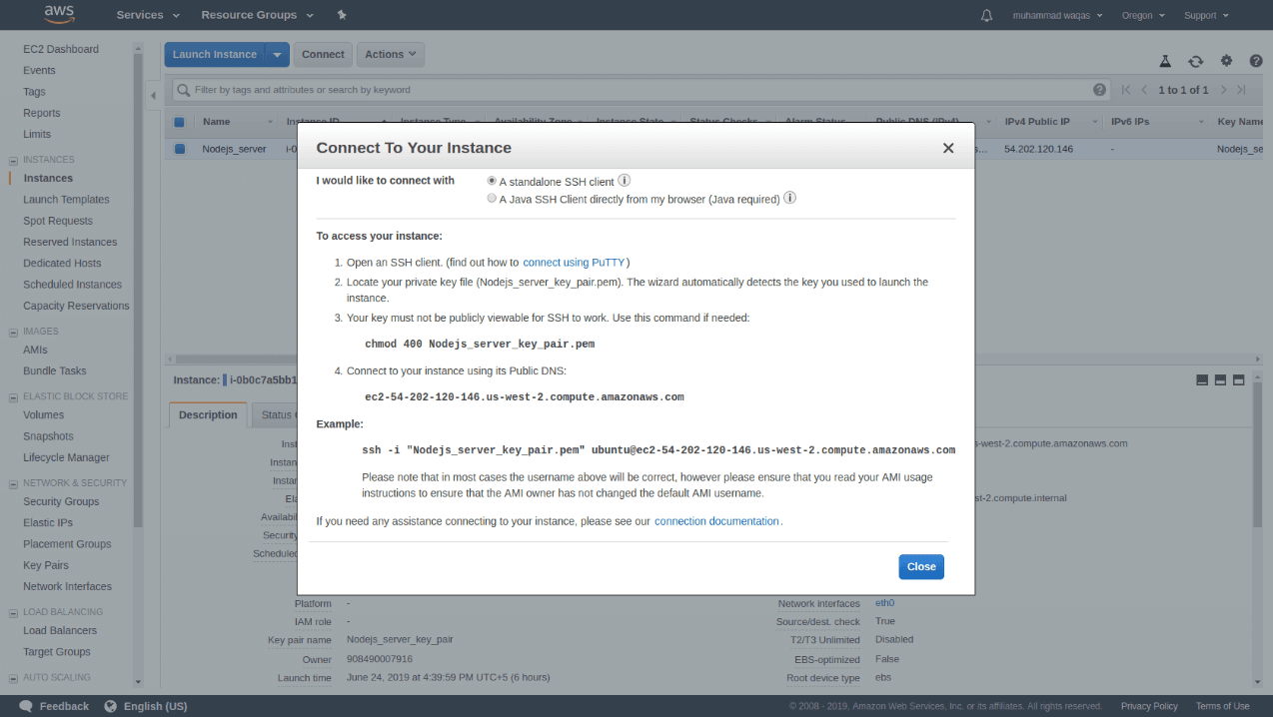

11.Copy DNS instances from the page and paste it in the browser and append port 3000 at the end of the address and now go to the security group in the AWS security groups and select the default group and edit the inbound rules.

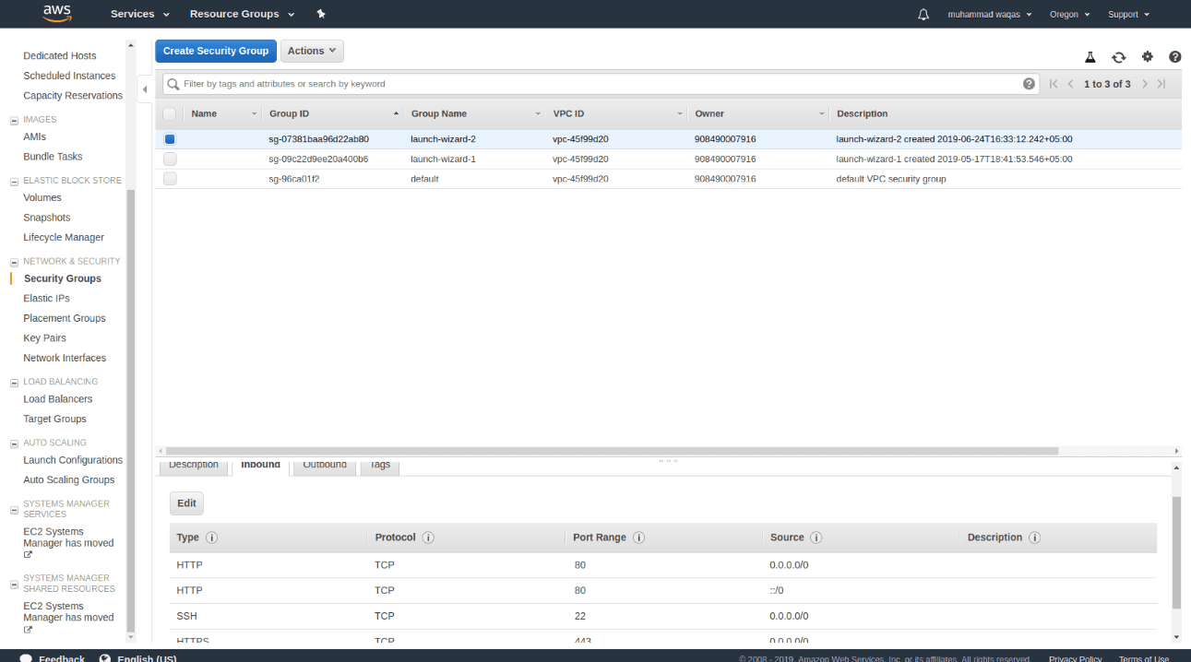

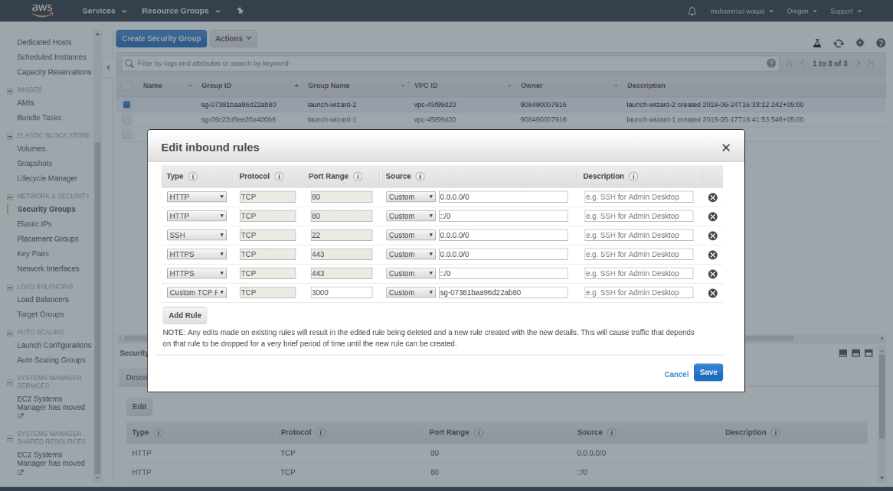

12.Access the URL again to see the output. The URL is <http://34.205.158.84:3000/>

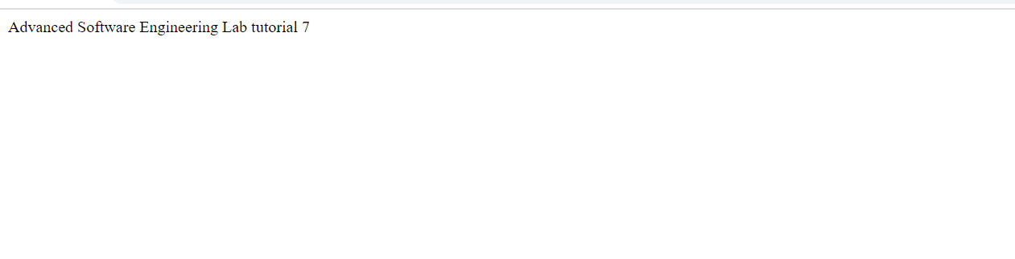

**Conclusion:**

From this experiment we can deploy a NODEJS application into the AWS Ec2 Instance

**Drawbacks:**

Repeatedly hitting or running the URL might cost us huge amount of money.

**YouTubeLink:**

https://youtu.be/ZgU_QJBhnsI

**References:**

<https://ourcodeworld.com/articles/read/977/how-to-deploy-a-node-js-application-on-aws-ec2-server>